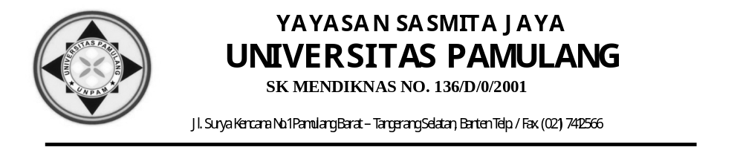

UJIAN AKHIR SEMESTER GANJIL
TAHUN AKADEMIK 2021/2022

Nama : Andri Firman Saputra NIM : 201011402125
Mata Kuliah : Bahasa Inggris 3 Hari/Tanggal : Rabu / 05-Januari-2022
Program Studi : Teknik Informatika Waktu : 8:50 - 10:30
Dosen : Sulasih, S.S., M.Pd. Sifat Ujian : Tutup Buku
Semester : 3 Shift : Reguler A

- Read the text and answer the following questions. (25 points)
MICROCOMPUTERS
The early 1970s saw the birth of the microcomputers, or micro for short. The central processor of micro, called the microprocessor, is built a single semiconductor device; that is, the thousands of individual circuit elements necessary to perform all the logical and arithmetic functions of a computer are manufactured as a single chip. A complete microcomputer ststem is composed of a micruprocessor, a memory and peripheral equipment. The processor, memory and electronic bits. Although minis can be equipped with much larger primary memory sizes, micros are becoming more powerful and converging with minicomputer technology.
The extremely low price of micros has opened up entirely new areas of application for computers. Only 20 years or so ago, a central processing unit of medium capability sold for a few hundred thousand dollars (U.S), and now some microprocessors sell for as cheaply $10. Of course, by the time you have a usable microcomputer system, the price will be somewhere between $10.000 depending on the display unit.
The available range of microcomputer system is evolving more rapidly than minicomputers. Because of their incredibly low price, it is now possible to use only a small fraction of the computer’s capability in a particular system application and still be far ahead financially of any other way of getting the job done. For example; thousands of industrial robots are in use today, and the number is growing very rapidly as this relatively new industry improves the price and performance of its products by using the latest microcomputers.
Even though the sotfware available for most microcomuter systems is very limited more so than for minis – it does not discourage their use in the many high-volume, fixed applications for which programming is especially a ‘one shot deal’ as is the case in the space shuttle program. In addition to their extensive use in control system of all types, they are destined for many new users from more complex calculators to automobile engine operation and medical diagnostics. They are already used in automobile emission control system and are the basis of many TV game attachments. There is also a rapidly growing market for personal computers whose application potential in education is only just beginning to be exploited.
It would seem that the limits for microcomputer applications have by no means been reached. There are those who predict that the home and hobby computer markets will grow into a multi-billion dollar enterprise within a decade or so. It would also appear that performance of microprocessors could well increase ten-fold before 1990 while prices for micros could decrease by as much. (English for Computer Science, Norma D. Mullen)

          - a. Write “T” for the true statements and “F” for the false on the line provided !
- It is s chip that consists of thousands of individual circuit elements. T
- Memory equipment is an element of a complete microcomputer system T
- Microcomputer instruction sets are more intricate than those of minicomputers. T
- The word length available of all sorts of microcomputers is only one type. F
- Although microcomputer becomes more powerful, they cannot meet the technology of minicomputer. F

b. Please create your own questions based on the reading text above
1. What is a microcomputers?
2. What are the advantages of a microcomputer?
3. What is better than microcomputers and minicomputers?
4. When was the minicomputer invented?
5. How to use a microcomputer for an automobile engine?

- Combine the sentences to form adjective clause, don’t forget to use the correct relative pronoun, and use the 2nd sentence as an adjective clause. (25 points)
- The lesson wasn’t easy which We did the lesson yesterday.
- We know the man very well Who wrote that book.
- The laptop formerly belonged to me that he is fixing the laptop now.
- I spoke to the professor yesterday who The professor teaches that subject.
- Is this the letter Which You wanted me to deliver the letter.
- The students are all in this class whose He knows the students.
- The mechanic found the difficulty that We hired the mechanic.
- He put the marker in the book which He was reading the book.
- I handed the telegram to the man Who The telegram had just arrived.
- She tried to remember the software Which She had learned the software last week.

III. Complete the sentences below using your own words to form the clauses (25 points)
- Noun clauses
- Why he chooses the Information Technology class is very complicated
- I want to know whose laptop that is in my table
- I don’t remember how many computers are in computer lab
- They don’t know who the leader of computer class
- Where I want to go, you always following me
- I know the new student who wrote that book

- Adjective Clauses
- This is the class where the students of information technology learning
- The student whose laptop is new is he
- The final examination that we are writing is English
- Today is the day when I take my license drive
- This is the book of computer that she wrote
c. Adverb Clauses
- After finishing his study in this class he went home
- You should always read a contract letter before you are issued
- Since she worked as a programming she rarely takes a food
- While the lecturer was lecturing to the class I listening
- Because they want to be a programmer, they study very hard

IV. Create your own sentences based on these folowing terms
a. a simple sentence
I speak english at Wednesday
b. a compound sentence
I tried to speak Japanese, and my friend tried to speak English

c. a complex sentence
Before Andre and Irgi arrived at the train station before noon, I did not see them at the station.

- a compound complex sentence
Though Devi prefers watching romantic comedy films, She rented the latest spy, and She enjoyed it very much.

